**Name:ARMSTRONG SELES A**

**Gmail:armstrongseles@gmail.com**

**Design Database for Zen Class Programme**

**Create database**

use zen_class

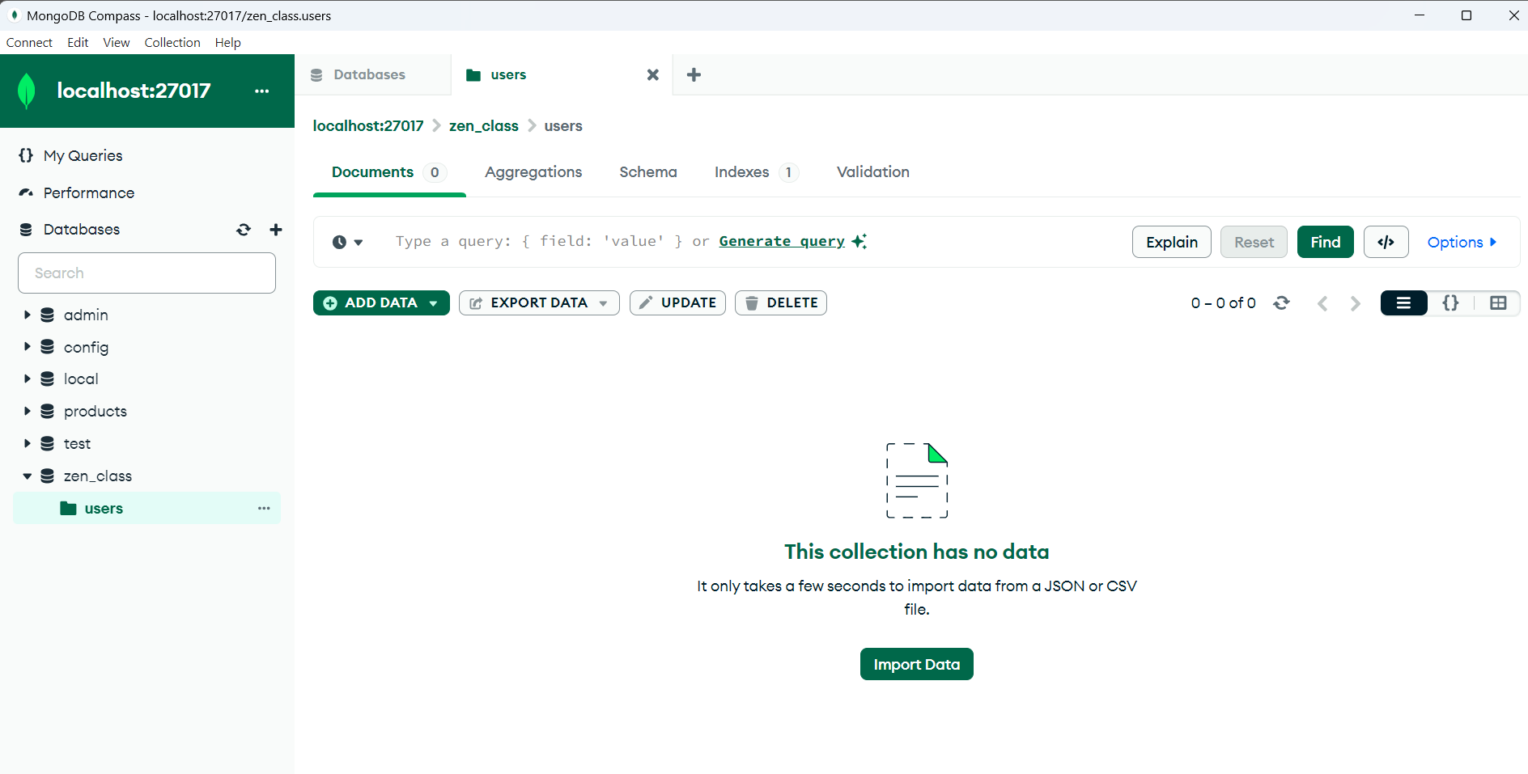

**Create collection and insert data – “USERS” :**

db.zen_class.users.insertMany([

{ user_id: 1, name: "Armstrong", email: "armstrong@example.com" },

{ user_id: 2, name: "Seles", email: "seles@example.com" },

{ user_id: 3, name: "Ruban", email: "ruban@example.com" },

{ user_id: 4, name: "David", email: "david@example.com" },

{ user_id: 5, name: "Arockiam", email: "arockiam@example.com" },

]);

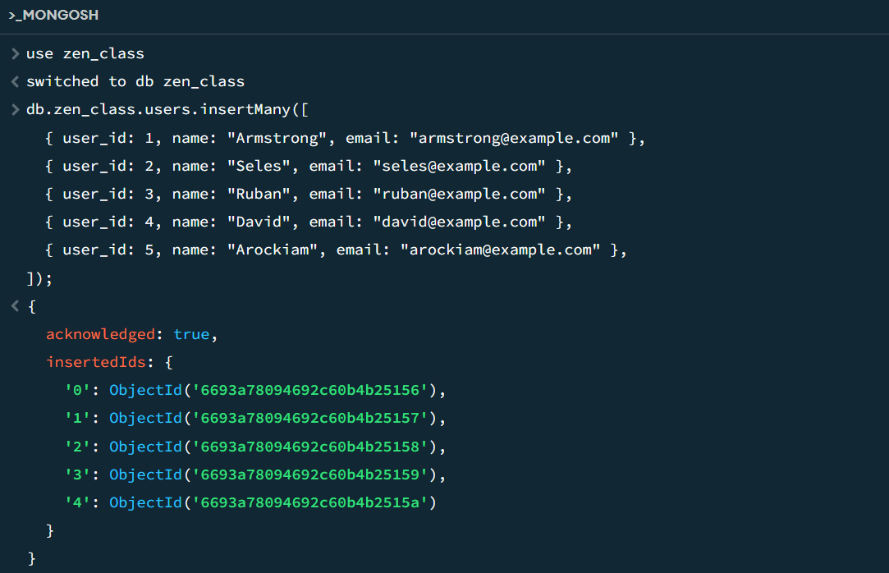

**Create collection and insert data – “CODEKATA” :**

db.zen_class.codekata.insertMany([

{ codekata_id: 1, name: “Java Basics”, difficulty: “Easy” },

{ codekata_id: 2, name: “Python Advanced”, difficulty: “Hard” },

{ codekata_id: 3, name: “JavaScript Fundamentals”, difficulty: “Medium” },

{ codekata_id: 4, name: “Algorithms in C++”, difficulty: “Hard” },

{ codekata_id: 5, name: “Data Structures in Python”, difficulty: “Medium” },

]);

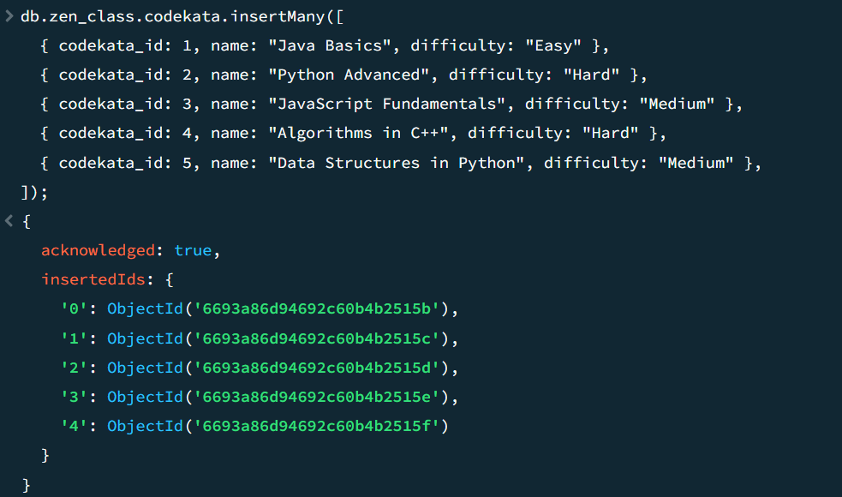

**Create collection and insert data – “ATTENDANCE” :**

db.zen_class.attendance.insertMany([

{ user_id: 1, date: ISODate("2020-10-15"), status: "Present" },

{ user_id: 2, date: ISODate("2020-10-20"), status: "Absent" },

{ user_id: 3, date: ISODate("2020-10-25"), status: "Present" },

{ user_id: 4, date: ISODate("2020-10-28"), status: "Absent" },

{ user_id: 5, date: ISODate("2020-10-30"), status: "Present" },

]);

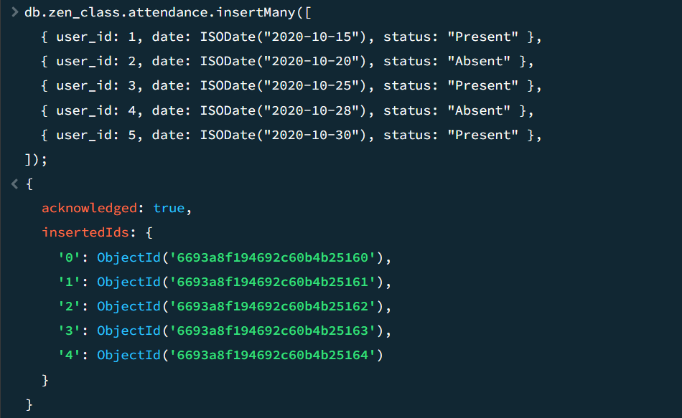

**Create collection and insert data – “TOPICS” :**

db.zen_class.topics.insertMany([

{ topic_id: 1, name: "Data Structures" },

{ topic_id: 2, name: "Algorithms" },

{ topic_id: 3, name: "Database Design" },

{ topic_id: 4, name: "Web Development Basics" },

{ topic_id: 5, name: "Artificial Intelligence Concepts" },

]);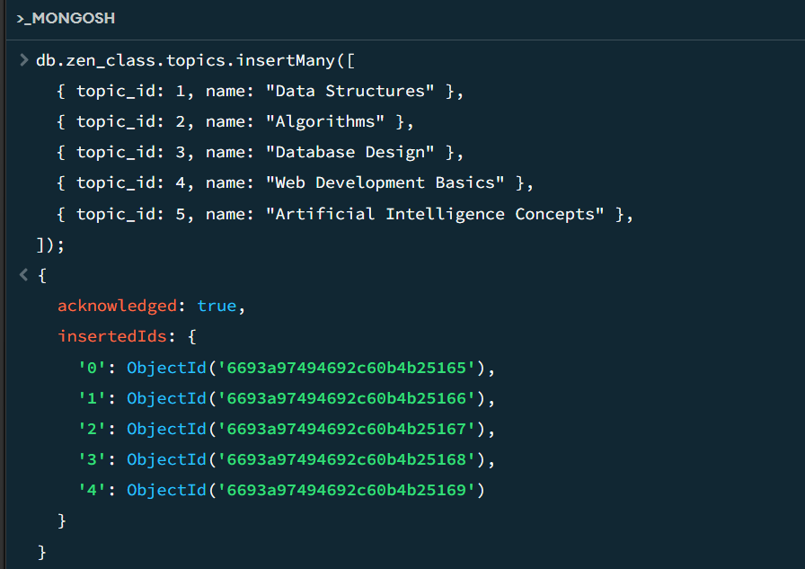

**Create collection and insert data – “TASKS” :**

db.zen_class.tasks.insertMany([

{ task_id: 1, user_id: 1, task_name: "Assignment 1", status: "Submitted" },

{ task_id: 2, user_id: 2, task_name: "Assignment 2", status: "Not Submitted" },

{ task_id: 3, user_id: 3, task_name: "Assignment 3", status: "Submitted" },

{ task_id: 4, user_id: 4, task_name: "Assignment 4", status: "Not Submitted" },

{ task_id: 5, user_id: 5, task_name: "Assignment 5", status: "Submitted" },

]);

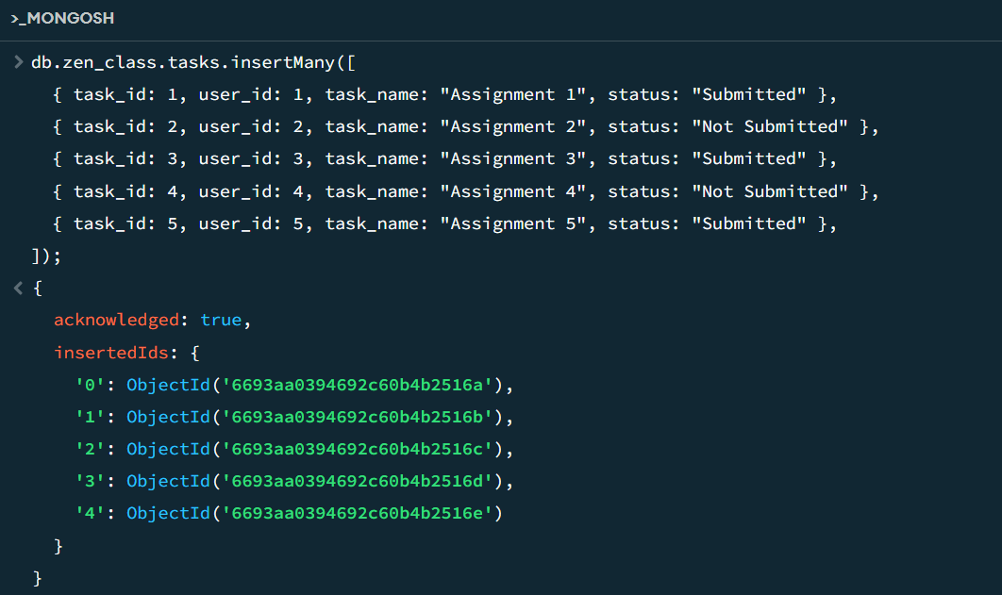

**Create collection and insert data – “COMPANY DRIVES” :**

db.zen_class.company_drives.insertMany([

{ drive_id: 1, name: "INFINITE COMPUTER SOLUTION", date: ISODate("2020-10-25") },

{ drive_id: 2, name: "ZOHO", date: ISODate("2020-10-28") },

{ drive_id: 3, name: "Amazon", date: ISODate("2020-10-20") },

{ drive_id: 4, name: "GUVI", date: ISODate("2020-10-30") },

{ drive_id: 5, name: "ARM Tech", date: ISODate("2020-10-31") },

]);

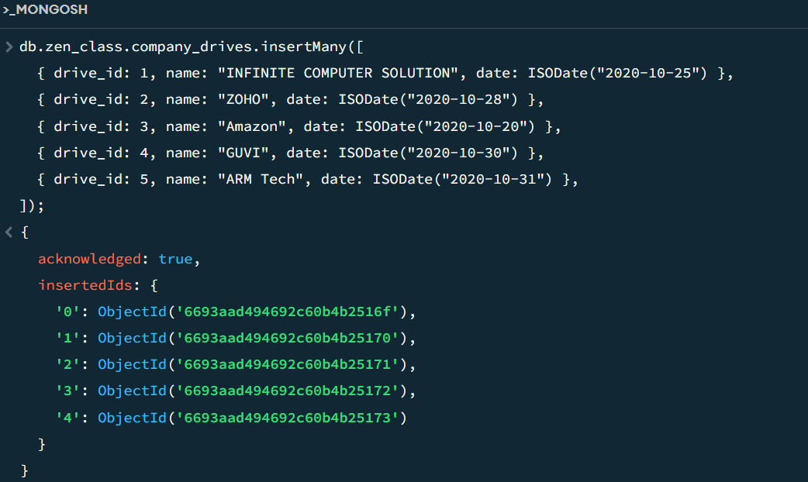

**Create collection and insert data – “MENTORS” :**

db.zen_class.mentors.insertMany([

{ mentor_id: 1, name: "Mentor1", mentee_count: 20 },

{ mentor_id: 2, name: "Mentor2", mentee_count: 10 },

{ mentor_id: 3, name: "Mentor3", mentee_count: 25 },

{ mentor_id: 4, name: "Mentor4", mentee_count: 18 },

{ mentor_id: 5, name: "Mentor5", mentee_count: 30 },

]);

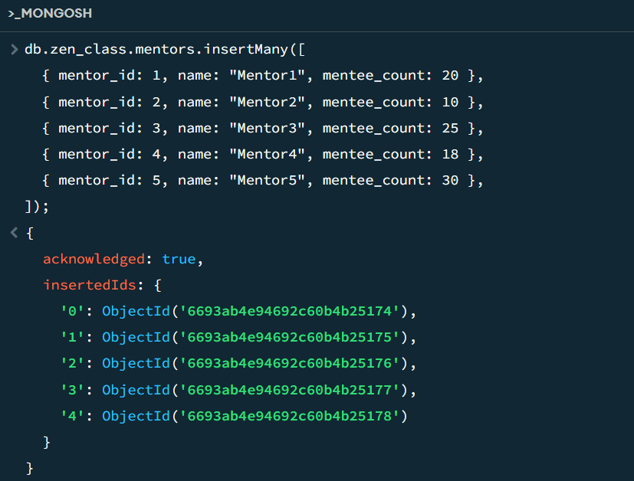

**CREATED DATABASE**

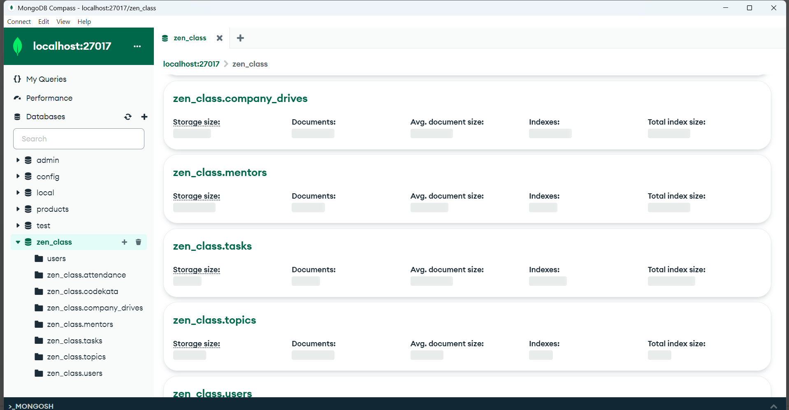

1. **Find all the topics and tasks which are thought in the month of October :**

**Solution :**

db.topics.aggregate([

{

$lookup: {

from: "tasks",

localField: "topicid",

foreignField: "topicid",

as: "taskinfo"

}

},

{

$match: {

$and: [

{ topic_date: { $gte: new Date("2020-10-01"), $lt: new Date("2020-11-01") } },

{

$or: [

{ "taskinfo.due_date": { $gte: new Date("2020-10-01"), $lt: new Date("2020-11-01") } },

{ "taskinfo.due_date": { $exists: false } }

]

}

]

}

},

{

$project: {

_id: 0,

topicid: 1,

topic: 1,

topic_date: 1,

tasks: "$taskinfo.task",

due_dates: "$taskinfo.due_date"

}

}

])



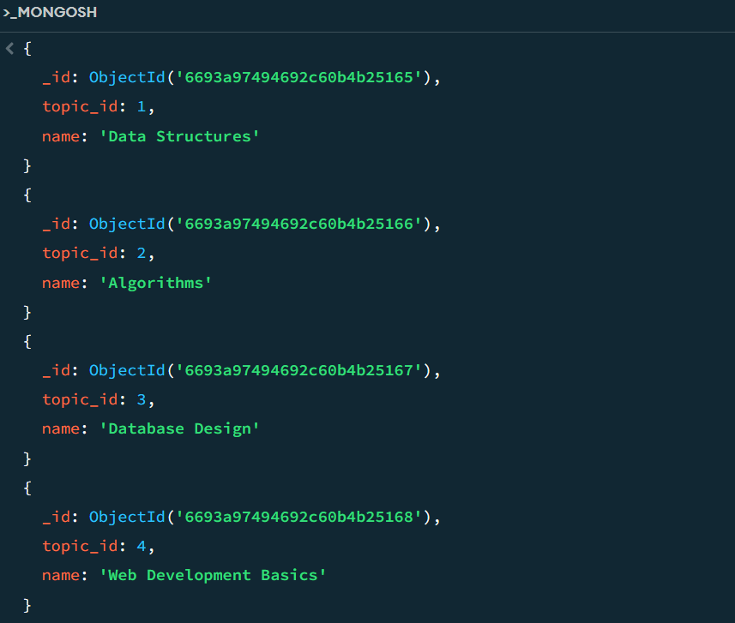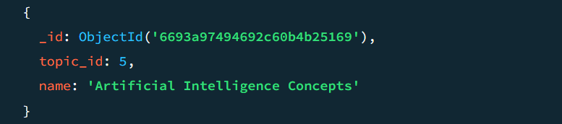

1. **Find all the company drives which appeared between 15 oct-2020 and 31-oct-2020 :**

**Solution :**

db.zen_class.company_drives.find({

date: { $gte: ISODate('2020-10-15'), $lte: ISODate('2020-10-31') }

});

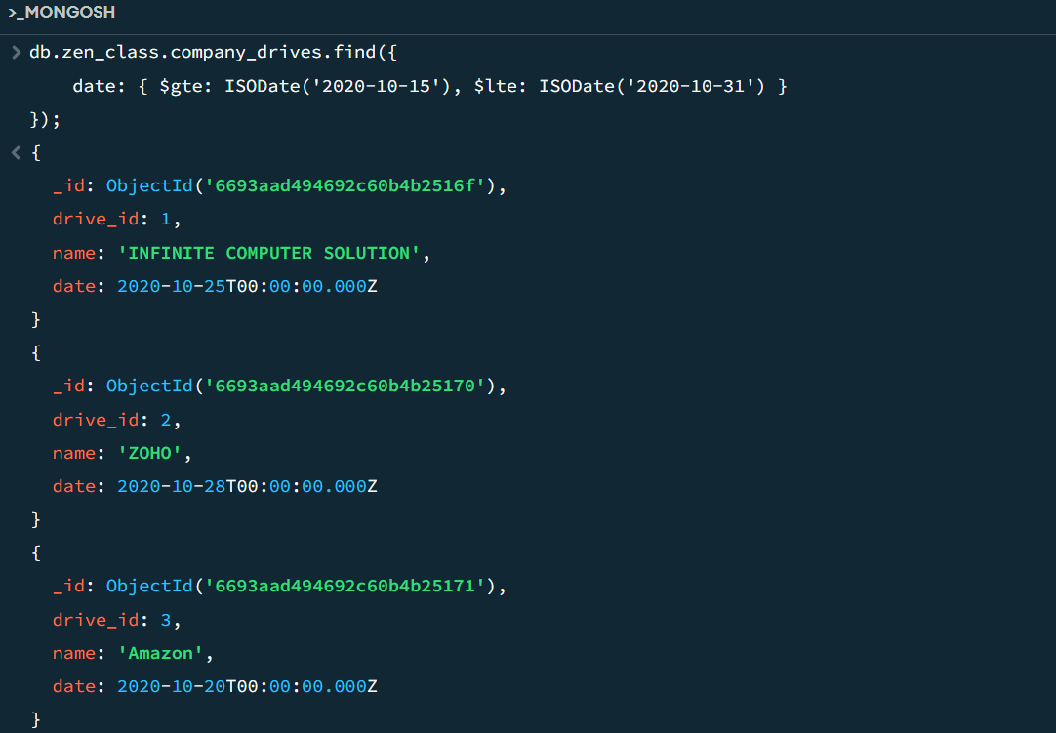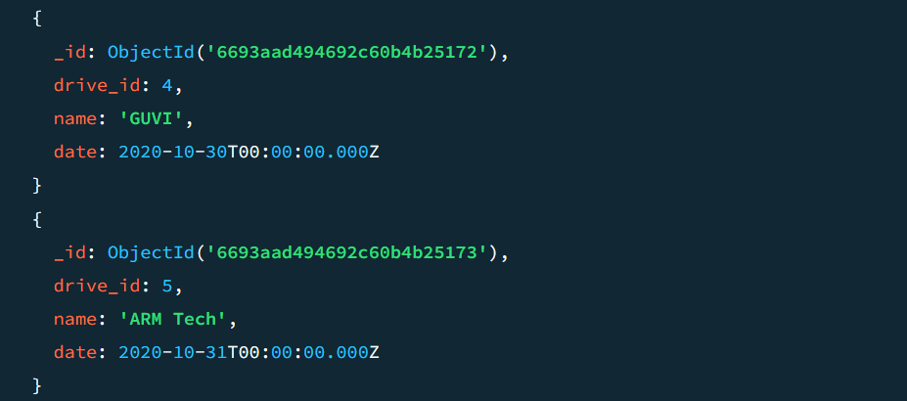

1. **Find all the company drives and students who are appeared for the placement :**

**Solution :**

db.zen_class.company_drives.aggregate([

{

$lookup: {

from: "attendance",

localField: "drive_id",

foreignField: "drive_id",

as: "drive_attendance"

}

},

{

$lookup: {

from: "users",

localField: "drive_attendance.user_id",

foreignField: "user_id",

as: "students"

}

},

{

$project: {

_id: 0,

drive_id: 1,

name: 1,

date: 1,

students: {

$map: {

input: "$students",

as: "student",

in: {

user_id: "$$student.user_id",

name: "$$student.name",

email: "$$student.email"

}

}

}

}

}

} ]) ;

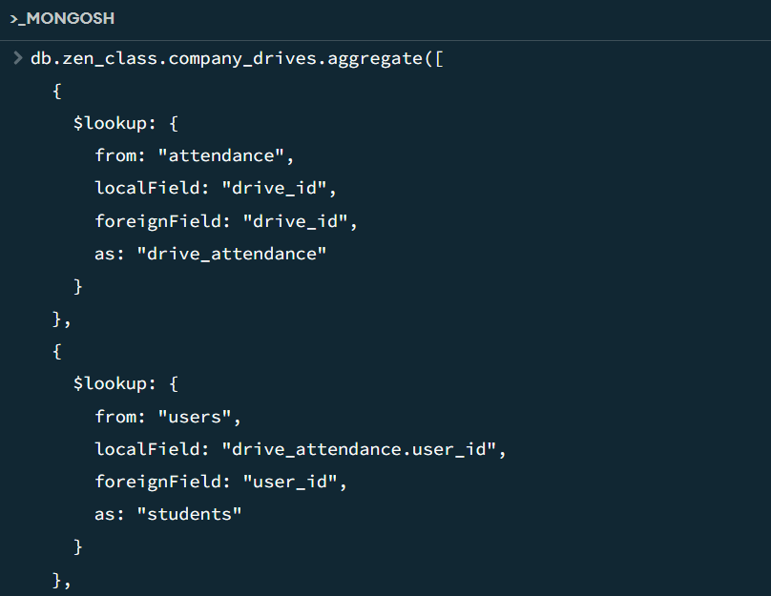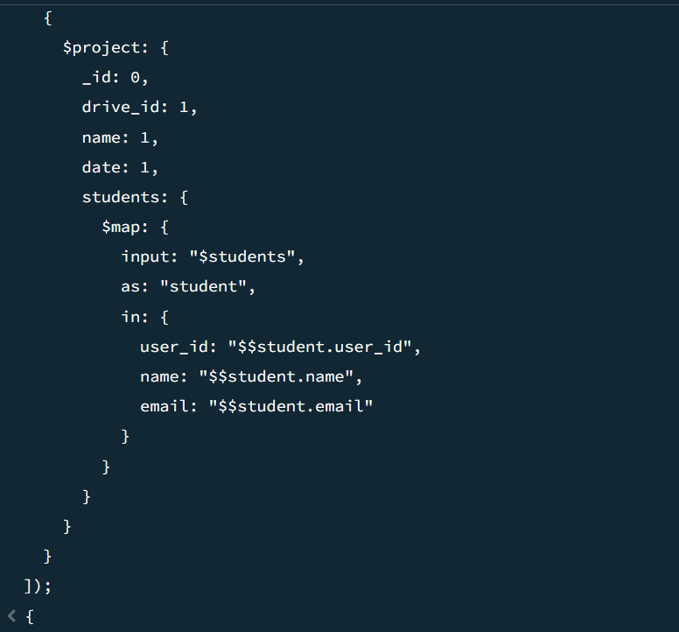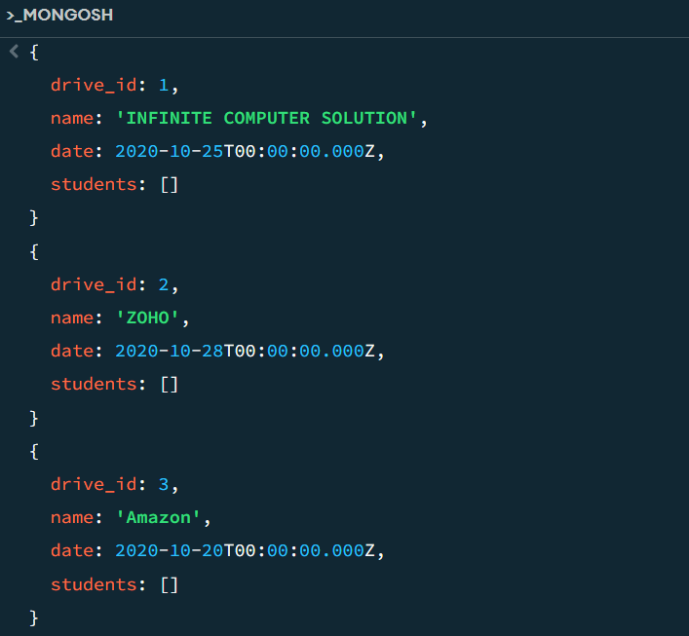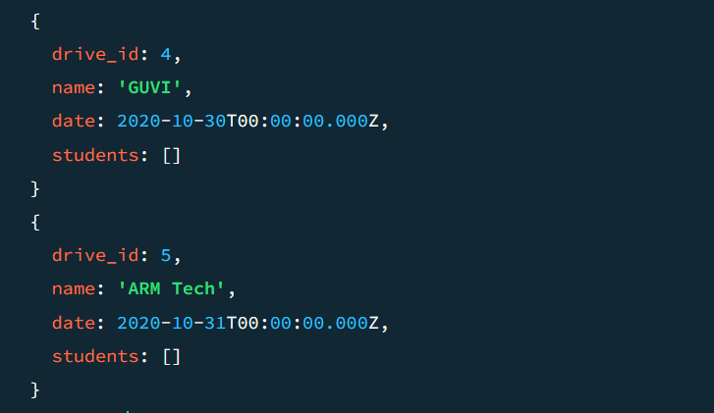

1. **Find the number of problems solved by the user in codekata :**

**Solution :**

db.zen_class.codekata.aggregate([

{

$lookup: {

from: "users",

localField: "userid",

foreignField: "userid",

as: "userinfo"

}

},

{

$group: {

_id: {

userid: "$userid",

username: "$userinfo.name"

},

total_problems_solved: { $sum: "$problems" }

}

},

{

$project: {

_id: 0,

userid: "$_id.userid",

username: "$_id.username",

total_problems_solved: 1

}

}

])

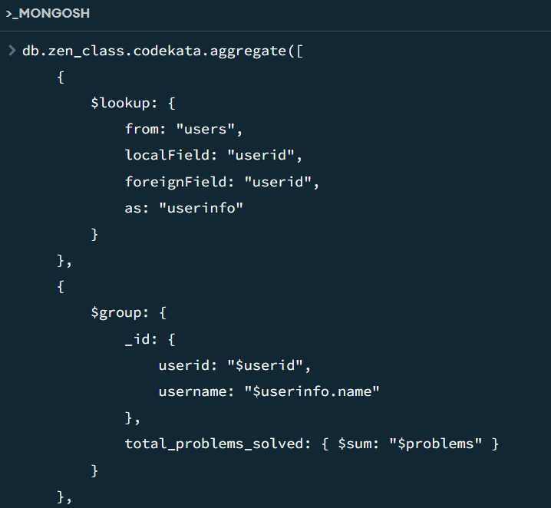 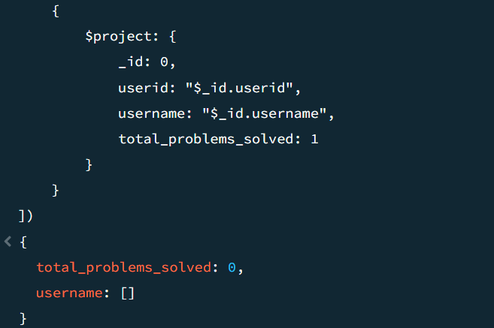

1. **Find all the mentors with who has the mentee's count more than 15 :**

**Solution :**

db.zen_class.mentors.find({ mentee_count: { $gt: 15 } });

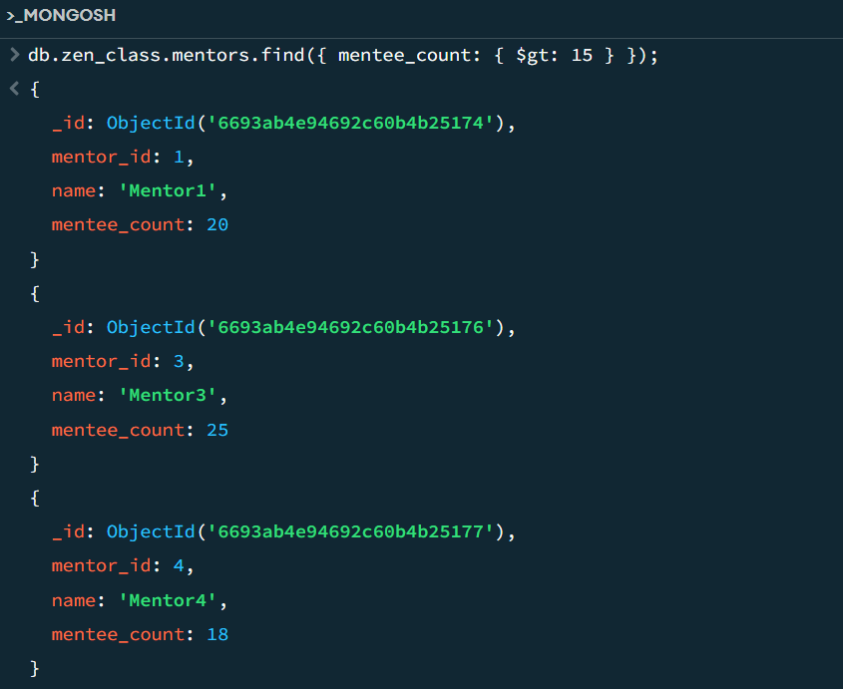 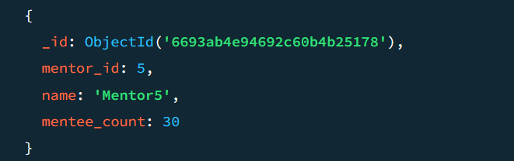

1. **Find the number of users who are absent and task is not submitted  between 15 oct-2020 and 31-oct-2020 :**

**Solution :**

db.zen_class.attendance.aggregate([

{

$match: {

date: { $gte: ISODate("2020-10-15"), $lte: ISODate("2020-10-31") },

status: "Absent"

}

},

{

$lookup: {

from: "tasks",

localField: "user_id",

foreignField: "user_id",

as: "task_info"

}

},

{

$match: {

"task_info.status": { $ne: "Submitted" }

}

},

{

$group: {

_id: null,

users_count: { $sum: 1 }

}

},

{

$project: {

_id: 0,

users_count: 1

}

}

]);

